CISCO PACKET TRACER :

Introduction :

Cisco packet tracer is an open source software that allows the users clearly understand the internals of day to day networking by allowing users to build their own network from scratch and doing all necessary configurations as in real life networking.

It comes with many real time networking devices , end hosts , connections and other networking related devices like sniffers etc.

It has two workspaces to work with. They are as follows :

1. Logical – More relevant workspace to learn the underlying protocols and communication strategies followed in network communication by allowing users to represent network topology visually showing routers, switches, PC and connections and also configurations , testing, sniffing etc.
2. Physical – Represents real world network setup with geographical locations like buildings , cities , rooms etc. It helps in visualizing cable distances and locations rather than networking internals.

Here after , workspace refers to Logical workspace.

1. In the bottom of workspace , all the devices required , connections can be chosen. To start with , Peer to peer network is formed as follows:

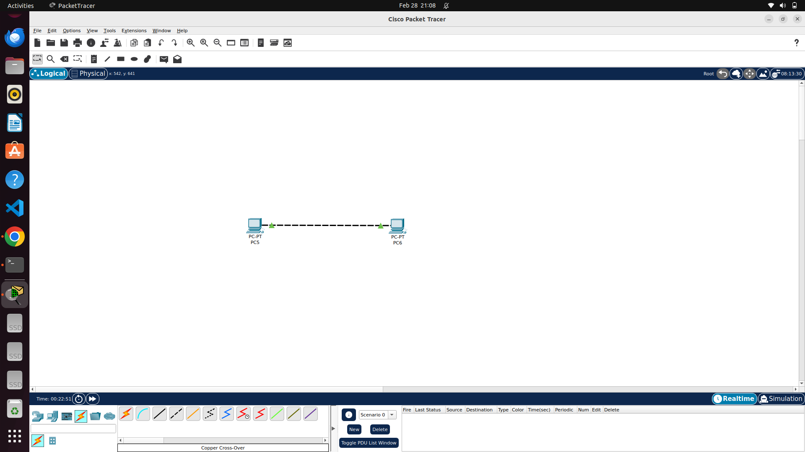

1. Here , two PC’s are connected via ethernet cross over cable (as they are of same kind). Then, double clicking on any pc will show multiple desktop options. In IP configuration option , IP , subnet mask , default gateway can be set. (MAC will be assigned automatically). Once set, it can be viewed using ipconfig command in command prompt as follows :

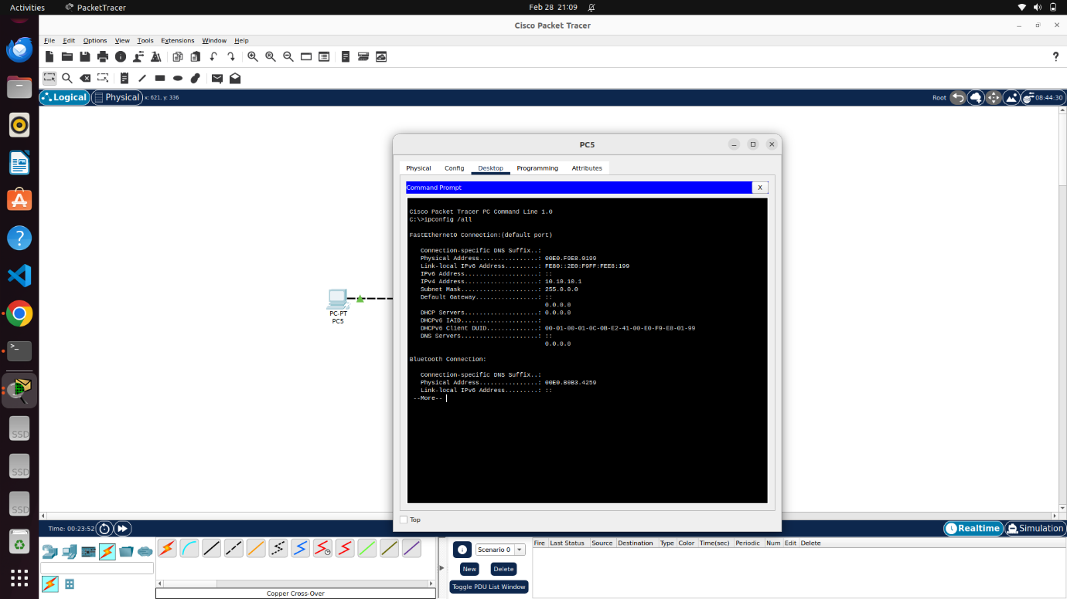

1. Connections can be checked by using ping command from pc 1 to pc 2 as follows :

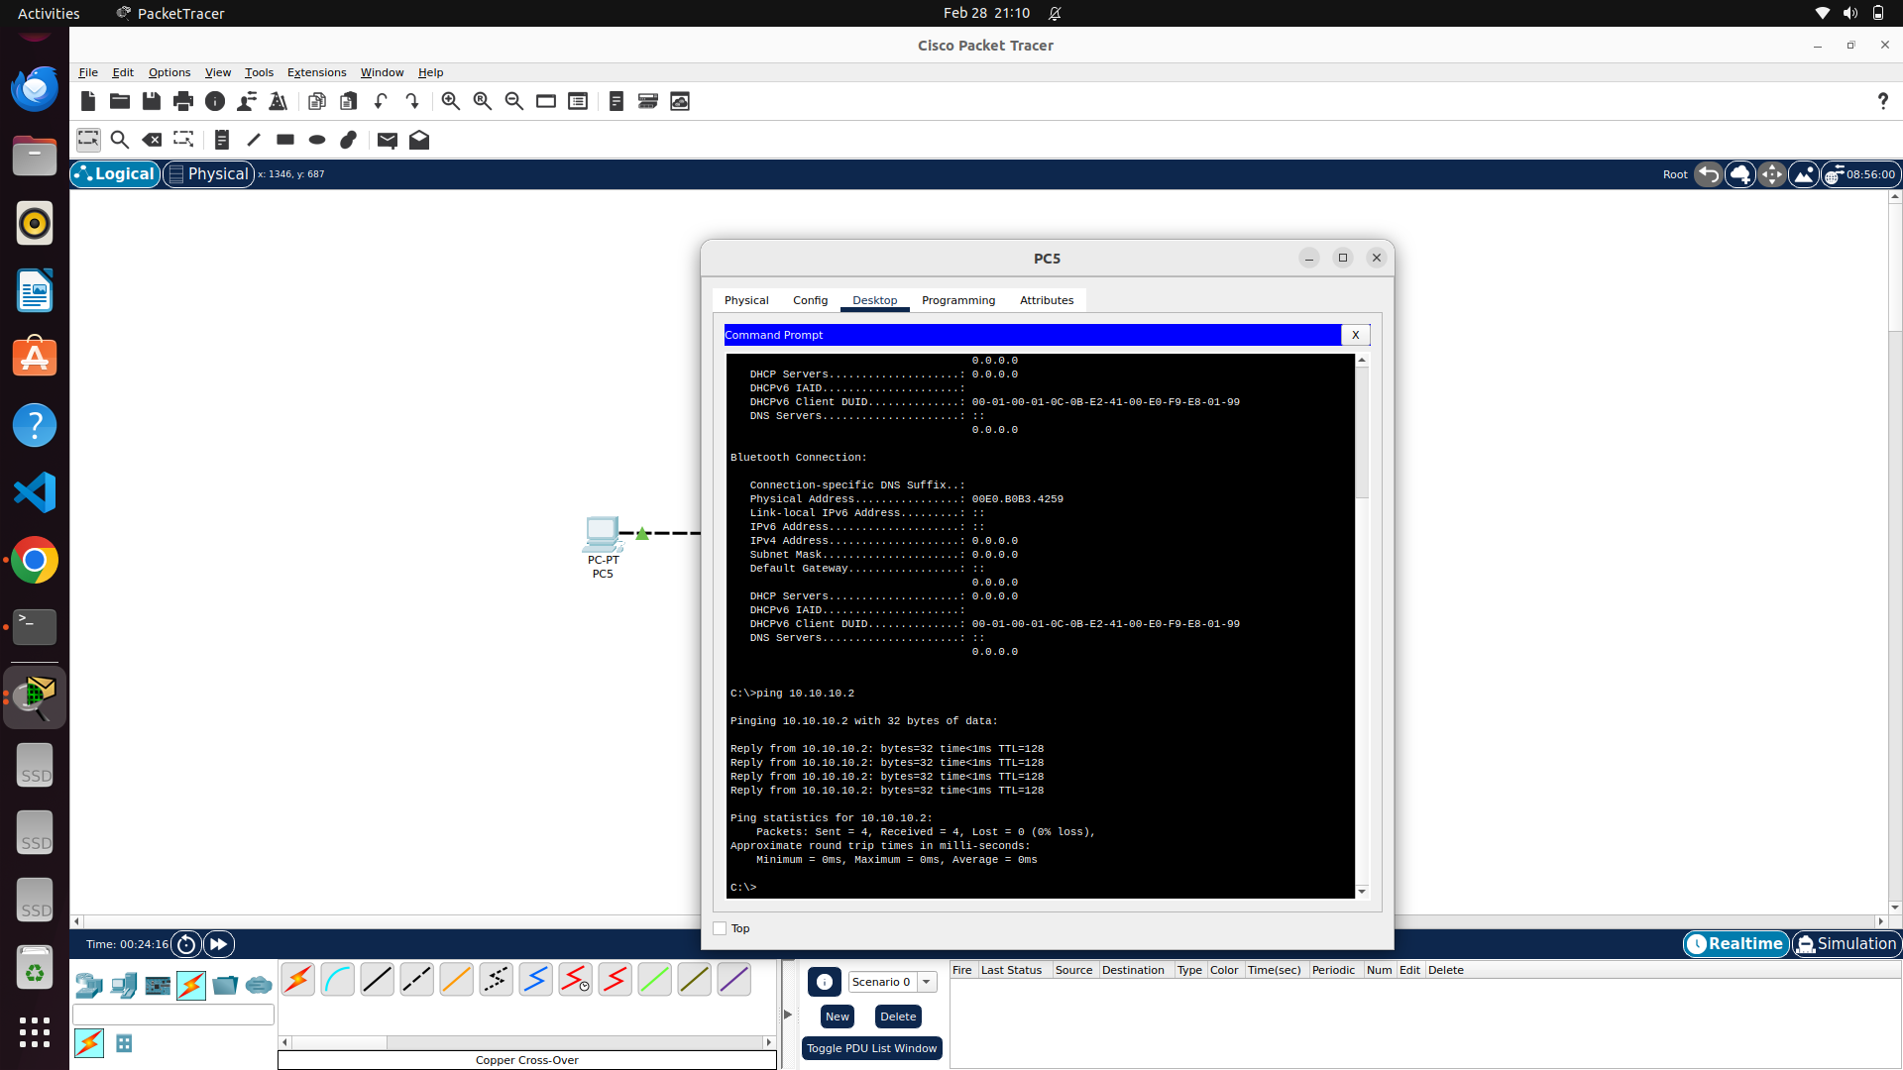

1. Hub is the layer 1 two port device which just sends the packet arrived to it to all other ports except source port (port of arrival). Hub based LAN can be formed as follows:

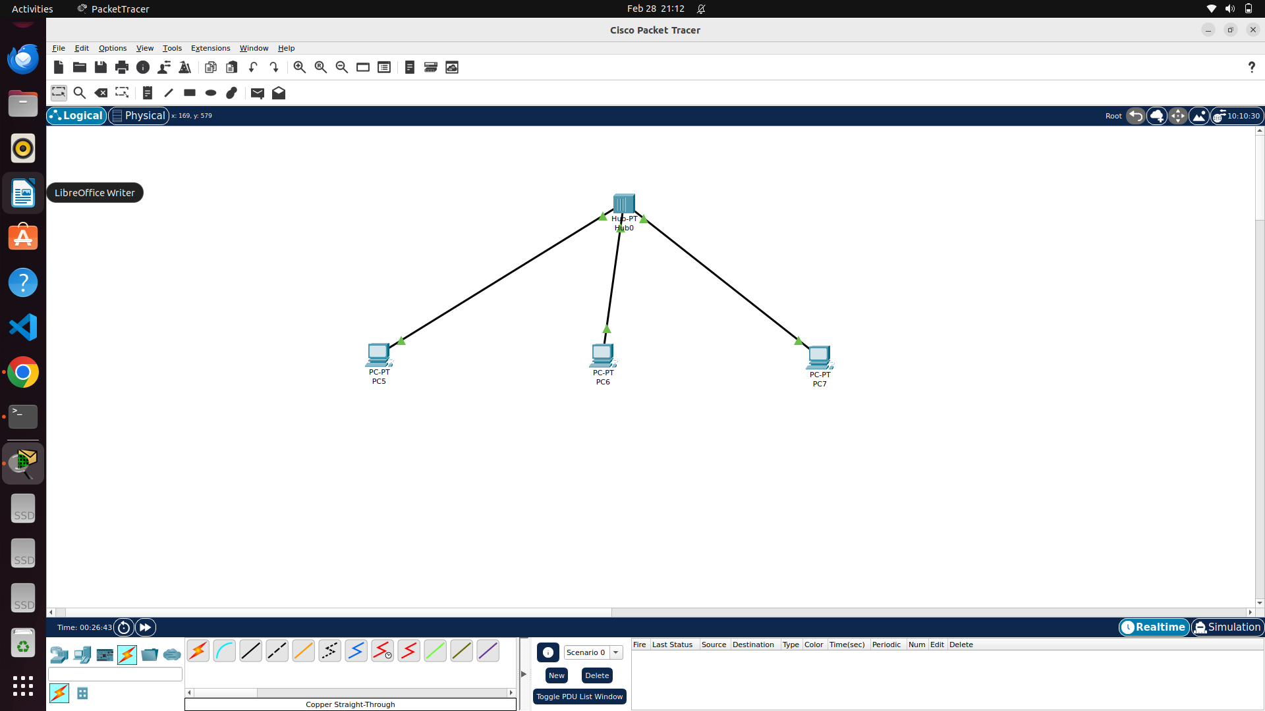

1. Working of hub is shown in following images:

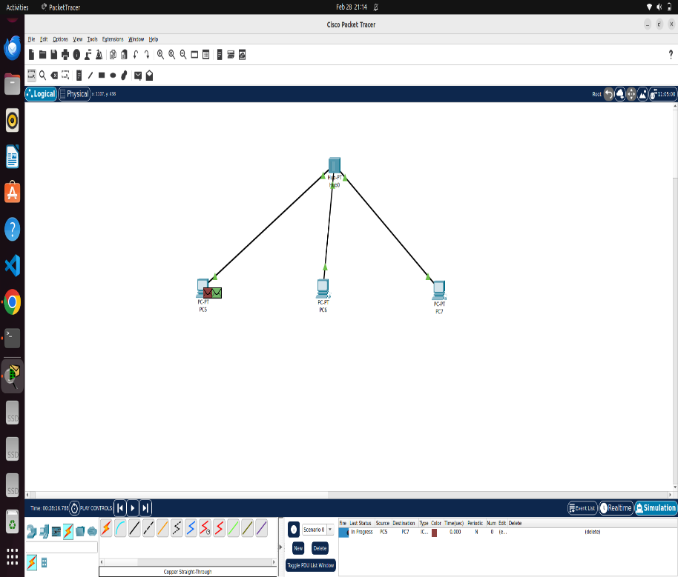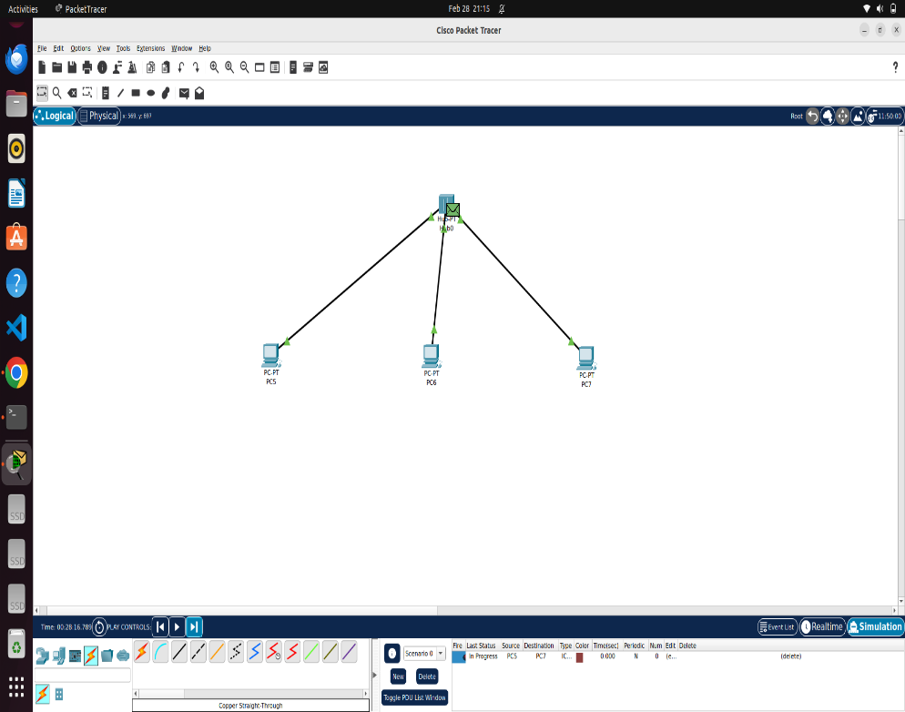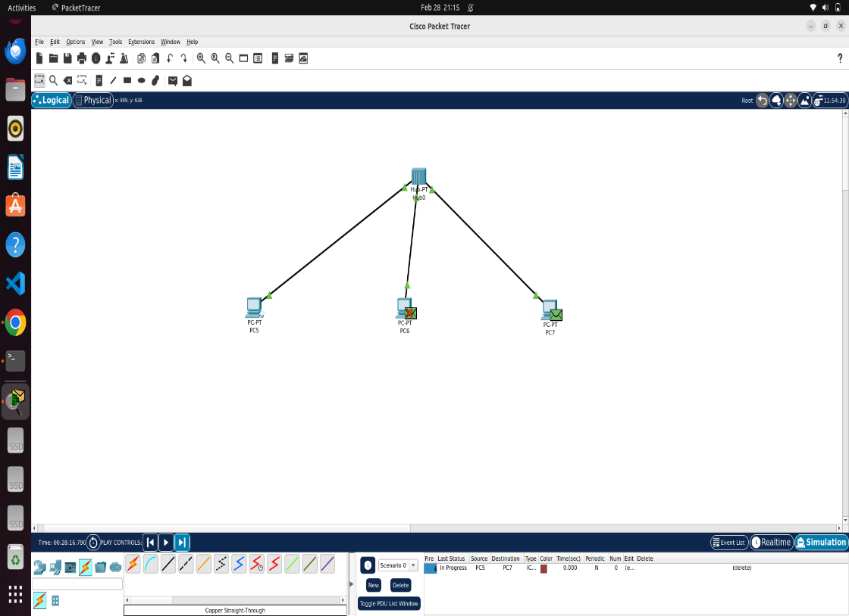

1. Switch is the layer 2 multi port device that works on the basis of MAC address in forwarding the packet to the required switch port instead of broadcasting. It maintains CAM (Content Addressable Memory) table. It learns MAC either by static entry from network admin or dynamically. Simple switch based LAN can be formed as follows : (After connecting , switch will take some time to learn about that device by sending SPT packet (Spanning Tree Protocol packet periodically to understand if any loops or topological change occurs) , DTP (Dynamic Trunk Protocol – for identifying chances to have Trunk access), CDP (Cisco Discovery Protocol) , Dynamic MAC learning)

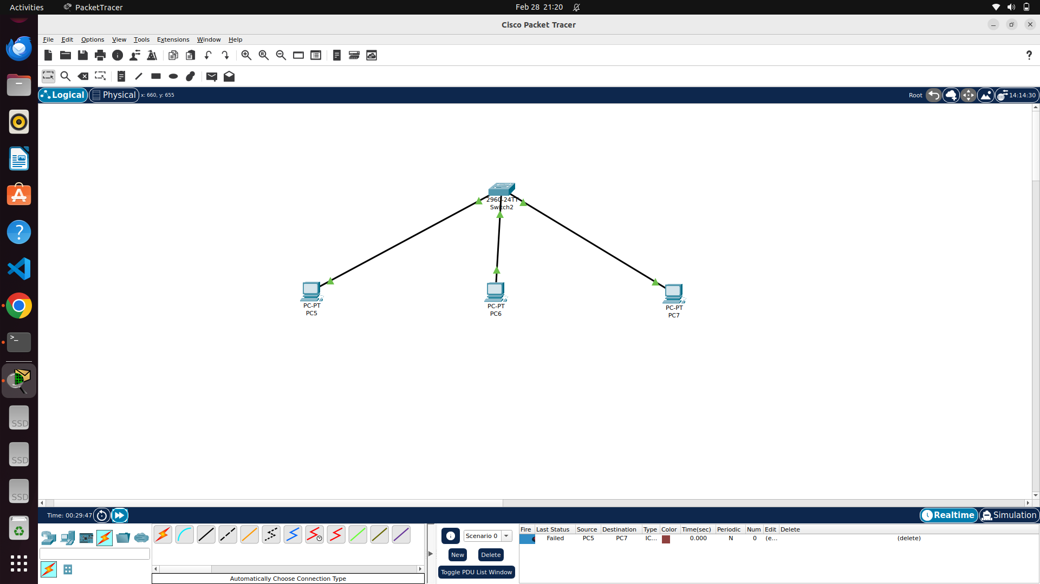

1. Sample MAC table for above network is shown below:

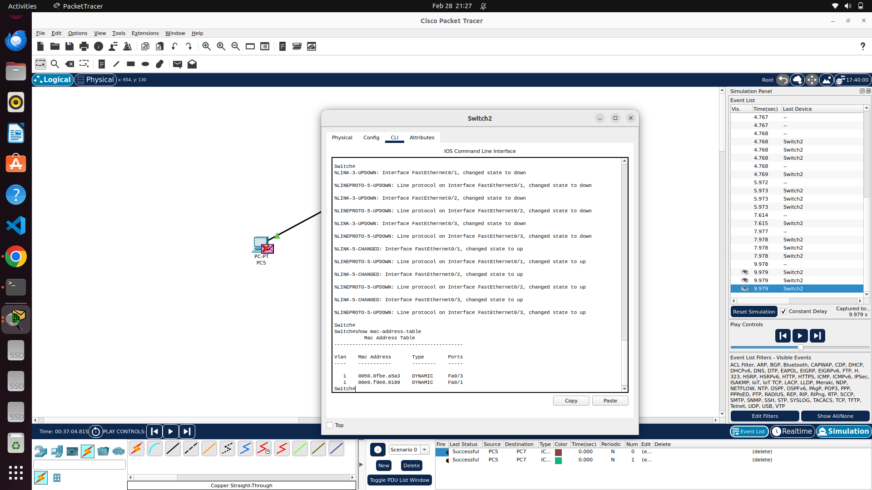

1. Router is the layer 3 multi port device which works on IP address and also on MAC address in forwarding packets to correct network interface. Each router interface will take up first IP (most probably) of the LAN it is attached to with its own MAC. It maintains routing table (static or dynamic) to forward packets based on the Network ID of IP address with subnet mask (by doing Logical AND between destination IP and subnet mask and expecting Long prefix match) so as to forward the packet based on MAC of the next hop. Simple Router based two LAN connection is shown below :

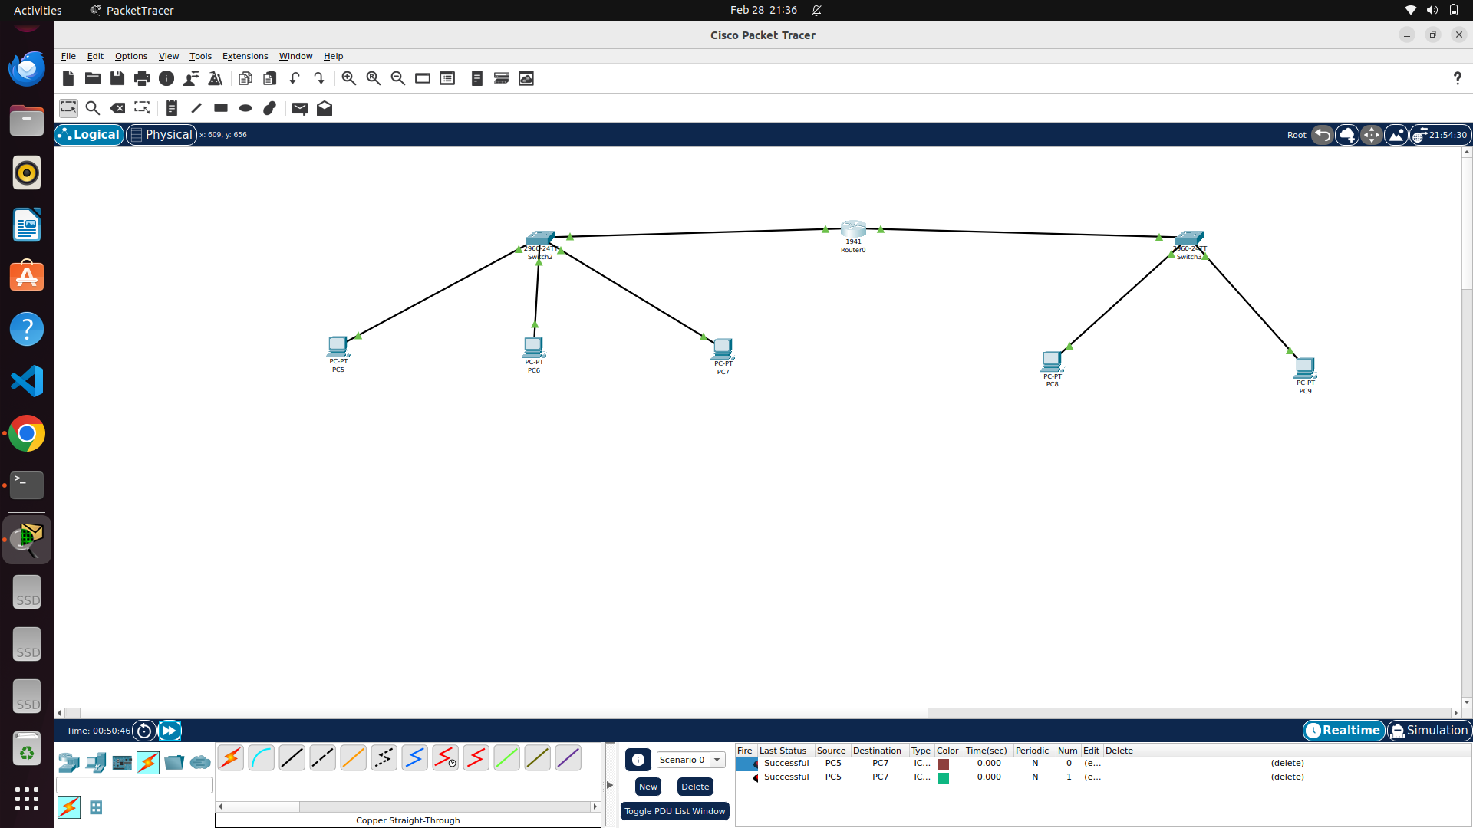

1. After giving connections , double click on router and in config window , using given GUI , ip , subnet mask of the router interfaces should be provided along with static routing table entries.
2. Any device if it wants to communicate to any other device checks the presence of destination device in its network by doing Logical AND between destination IP and subnet mask and expects its own network ID. If not so , it chooses default gateway as next hop via switch.
3. Based on above connections ,Lets take a scenario of having two LAN networks with switches in each network containing two PCs as end host devices with two routers as intermediate nodes as follows:

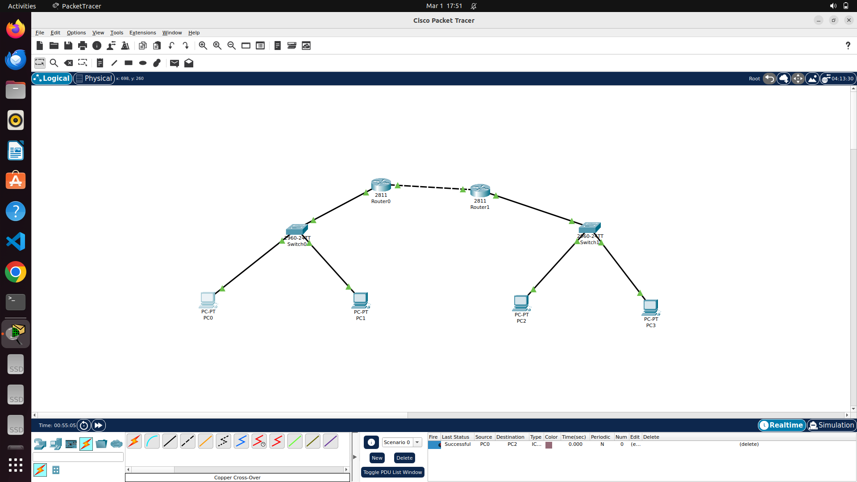

PC -0 : IP – 192.168.1.2/24

PC -1 : IP – 192.168.1.3 /24

Router – 0 Interface – 0 : IP – 192.168.1.1/24

Router – 0 Interface – 1 : IP – 10.0.0.1/255.255.255.252 (Part of peer to peer n/w)

PC – 2 : IP – 192.168.2.2/24

PC – 3 : IP – 192.168.2.3/24

Router – 1 Interface – 0 : IP – 10.0.0.2/255.255.255.252 (part of peer to peer n/w)

Router – 1 Interface – 1 : IP – 192.168.2.1/24

1. Cisco packet tracer allows the use of Sniffers to sniff the packets in particular network interface in which it is connected to as follows : (Sniffer is introduced between switch of LAN 1 and router – 0 in above image)

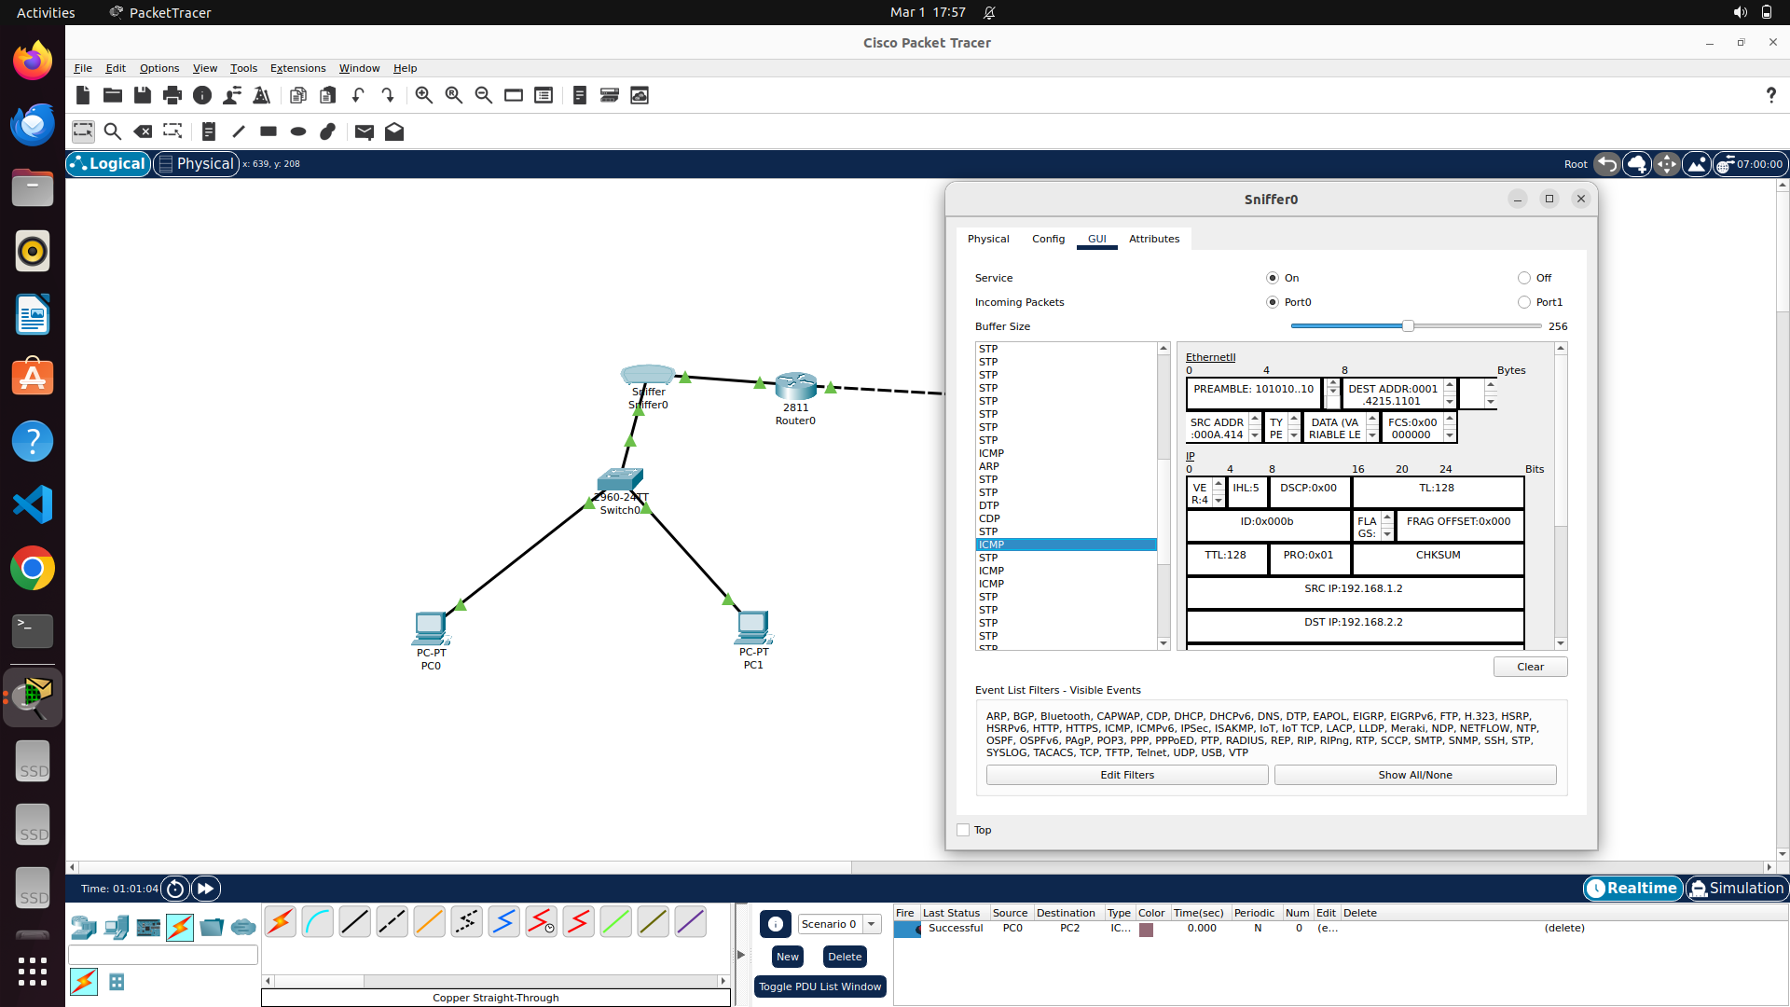

Sniffer window is opened in above image and list of packets it captures is presented in left side panel. To demonstrate , ping command from pc – 0 (192.168.1.2) (lan – 1 ) to pc – 2 (192.168.2.2)(lan - 2) is done and corresponding ICMP packet is expanded for view here.

CONCLUSION :

Thus Cisco packet tracer tool is explored by using logical workspace , using various networking tools like switch , hub, router etc with appropriate connections and configurations and explored the usage of sniffers in cisco packet tracer with example network.